,

Lab5 : Map Designer

Creating a Simple Map

Objective

Equip you with the knowledge and understanding of the purpose of the Map Designer and creation of a map.

- By completing the exercises you will learn how to create a map:
- View and understand input/output cards.
- This exercise also introduces creation of functional map
- Opening a functional map wizard.
- Mapping elements from source to target.
- How to build and run a map.
- Viewing run results.

Map Designer

The Map Designer is a client component of the Design Studio,used to develop maps that define input and output specifications and mapping rules for data transformation.
The Map Designer uses the definitions of data stored in the type trees (that are created using the Type Designer) to specify the transformation logic in the form of map rules. Map rules operate on input data objects and build output data objects. The map can be built for specific platforms, and then run on that platform to perform the transformation of the data.
During the design phase, maps are build and run within the Map Designer on a Windows platform. You can view the results of a map in the Map Designer. You can also use the Map Designer to build a map to be run on another platform.

The Map Designer is the application in the Design Studio that is used to specify data transformation logic in the form of map rules.
The Map Designer uses the definition of data objects created in the Type Designer as inputs and outputs and provides the functionality to specify rules for the transformation and routing of data.
Maps are analyzed, compiled, and tested using the Map Designer. Each map defines input and output specifications. Map rules entered in the Map Designer operate on input data objects and build output data objects

Map and Map Source file
The tasks involved in creating and managing map files include:
- Creating map source files (.mms)
- Creating maps in the map source file
- Creating input and output cards for the map
- Building compiled maps (.mmc)
- Running maps
- Viewing run results
A map defines how to generate a data object of a certain type or multiple independent data objects, each of a certain type. A map contains input and output cards that transform data content from source formats to destination formats according to rules contained in the map.
A map source file is used to store maps that are related to one another. A map source file is a file you create and save using the commands on the File menu in the Map Designer. A map source file has the file name extension .mms. A map source file maintains maps in source format. Map source files contain maps and functional maps.
After starting the Map Designer, the Navigator lists one or more map source files depending on whether you selected to create a new map source file or to open one or more existing map source files. The full path and filename of the map selected in the Navigator appear in the title bar of the Map Designer window.
After a map source file is created, the map source file name and icon appear in the List view of the Navigator.
The Composition view of the Navigator displays a map only after an input or output card has been added to the map.
Maps are not executed directly from a map source file. You must first build (compile) a map before you can execute it. Compiled maps have the file name extension .mmc.

Environment

Windows OS, IBM WTX8.4 Design Studio.

List of components

1. Input type tree – Employees.mtt
2. Output type tree – Employees.mtt
3. Input file name – EmployeeDetails.txt
4. Output file name – OUT_EMP.txt
5. Map Source name – EmployeeMap.mms

Procedure

The Map Designer in the Design Studio uses the definition of data objects created in the Type Designer as inputs and outputs and provides the functionality to specify rules for the transformation and routing of data. Map is analyzed, compiled, and tested using the Map Designer. Map rules entered in the Map Designer operate on input data objects and build output data objects.

Step 1 :

Start menu->Programs-> WebSphere Transformation Extender 8.4 ->Design Studio->Design Studio

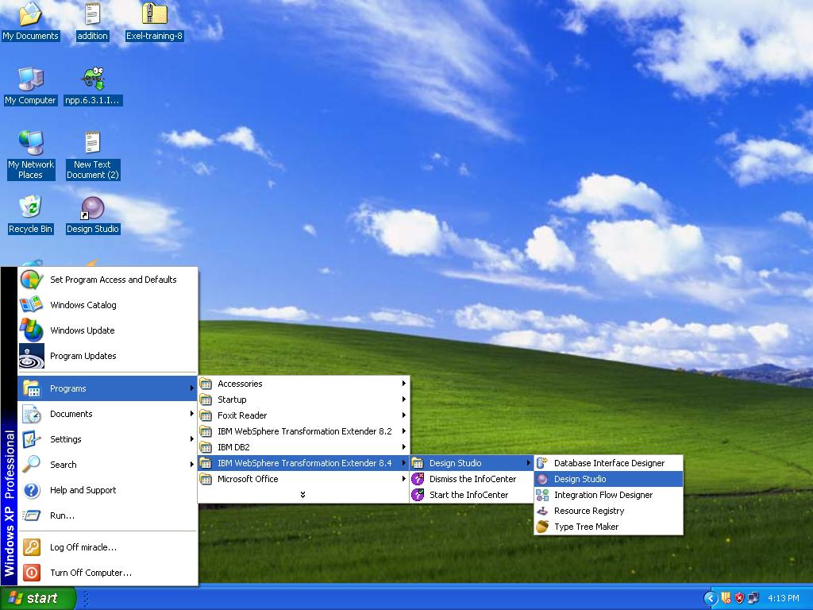

Step 2 :
Open the WebSphere Transformation Extender Design Studio and click the OK button to accept the default workspace location or you can browse your own location.
Here location C:\WTXTraining\WTX8.4 has been used.
The workspace is the physical directory where your artifacts will be stored.

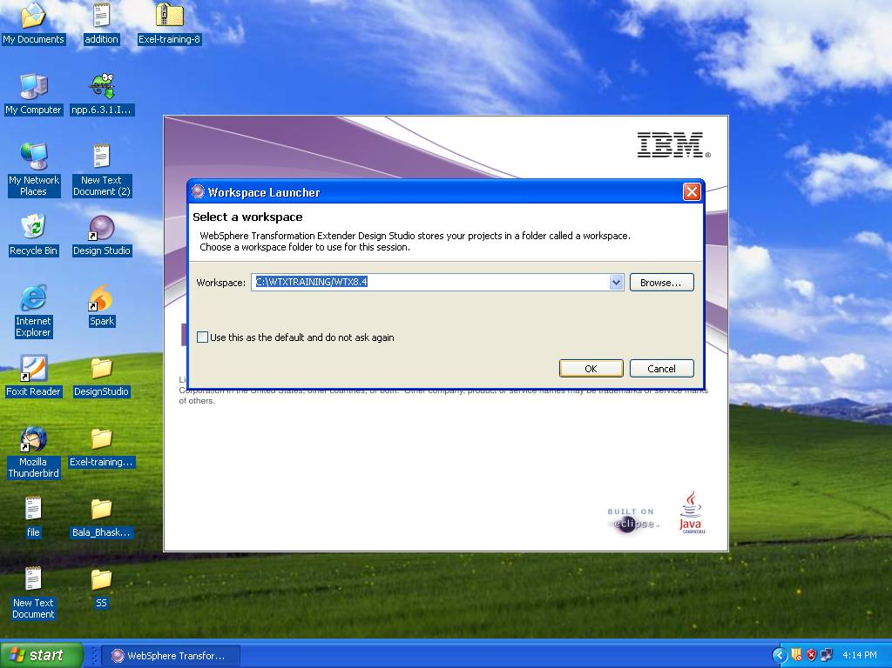

Step 3 :

Go to the file menu and select New->Extender Project to create a new project

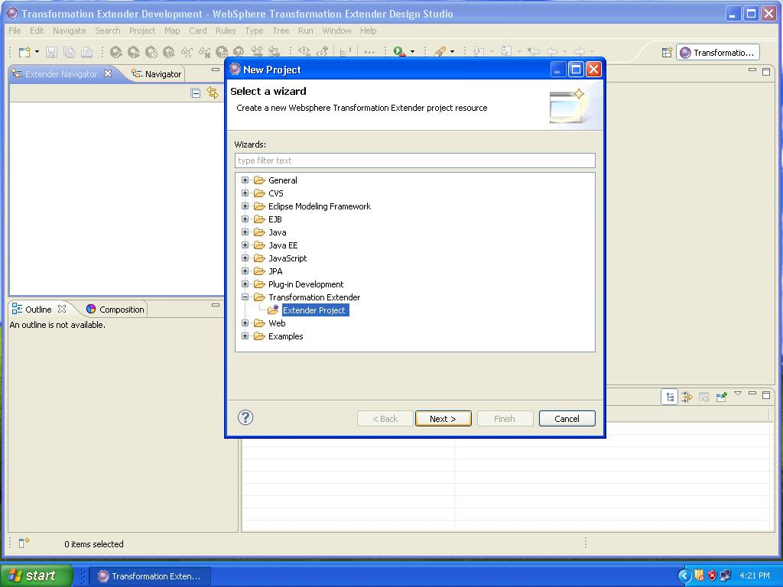

Step 4 :

Name this project WTX_Lab5 and accept the default location and click Finish.
You have created a subdirectory called WTX_Lab5 in your default workspace.
You can use Windows Explorer to view it.

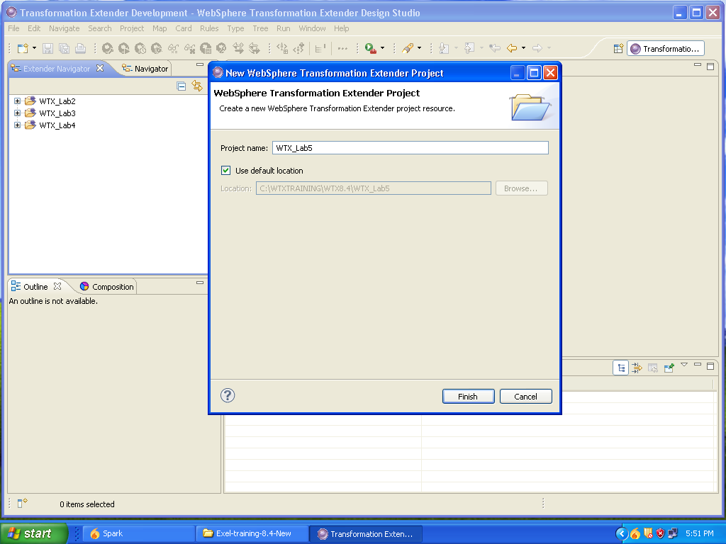

Step 5 : Create Source Map

Map source files contain one or more maps. It is logical to organize your maps in map source files according to use or purpose. It can contain many maps, each of which is reusable.

Right-click Map Files in the Transformation Navigator and choose New->Map Source
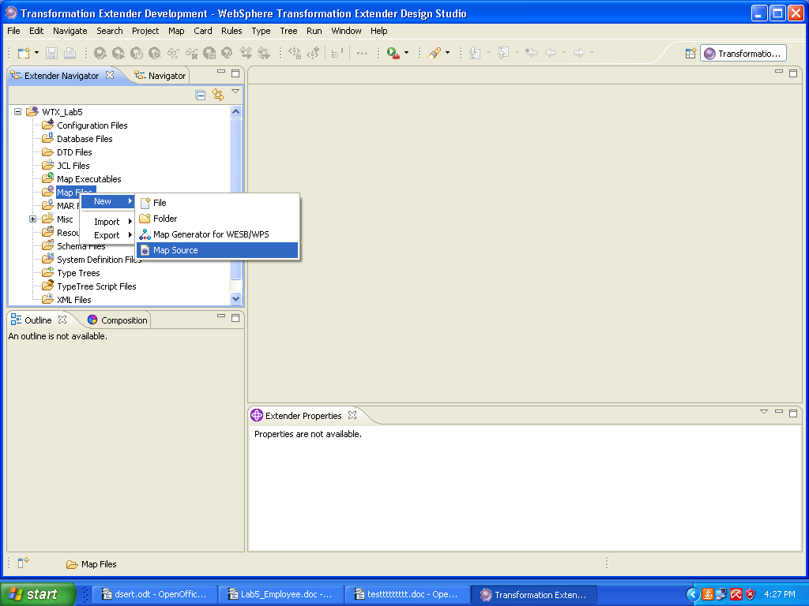

Step 6 :

Click WTX_Lab5 to move it to the “Enter or select the parent folder” window. Type EmployeeMap into the File name field. Click Finish.

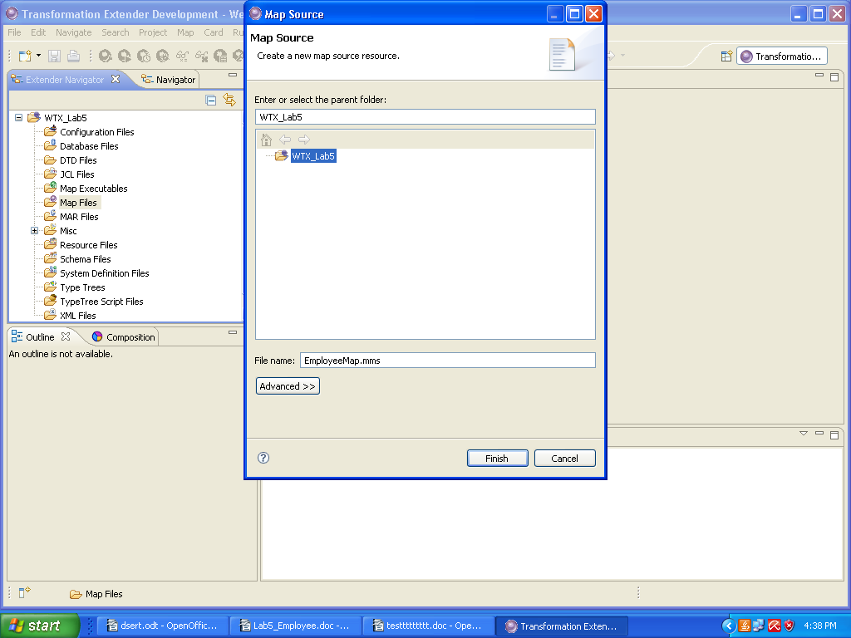

Creating the main executable map (compiled map)

Step 7 :

Click New map icon as shown in the below

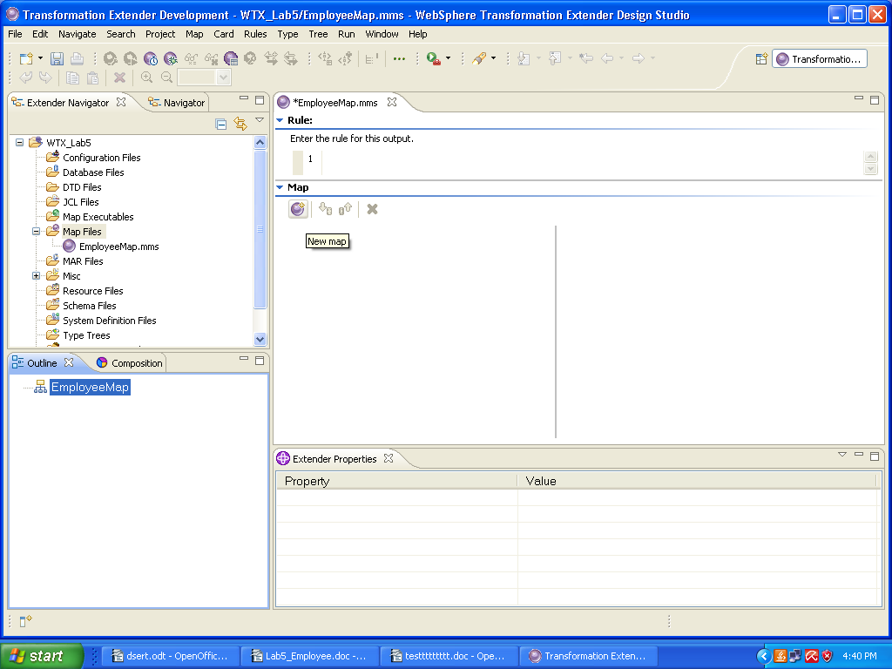

If you have Composition view open, you will not see the new map. That’s because the Map Designer doesn’t know yet how it’s going to be used. Switch to Outline view.

Step 8:

Right click NewMap1, choose Rename and type Employee as the new map name,

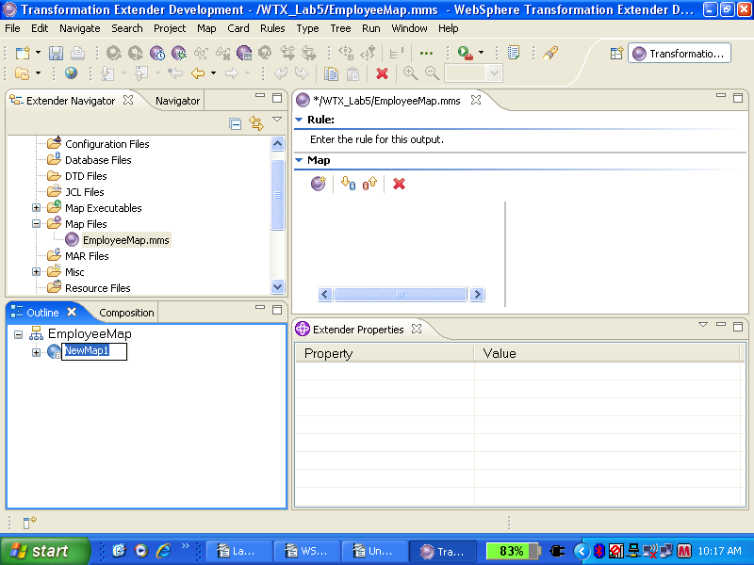

Type as Employee and click OK. This will be our executable map.
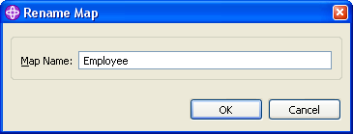

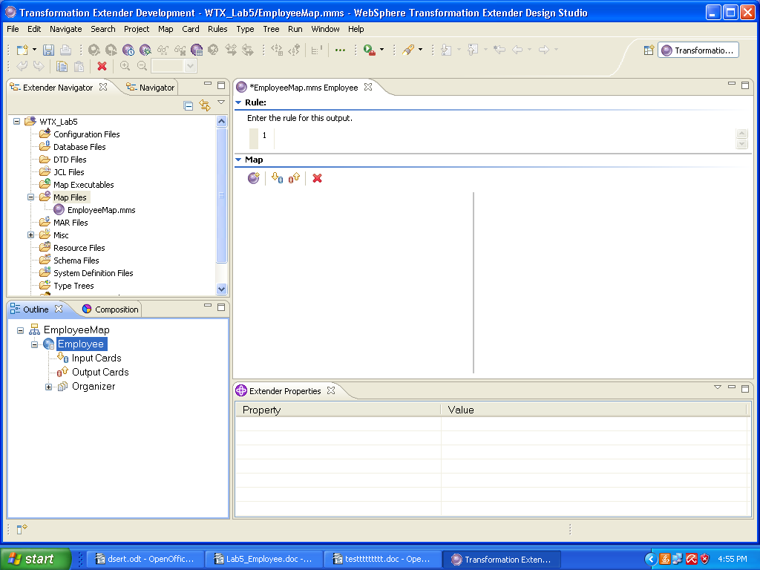

Step 9 :

To create an input card
A map contains input and output cards that transform data content from source formats to target formats. ( For further details on Input and output cards see Appendix A )
Select the Input Cards element under the map in the Outline view. On the Card menu, click New.

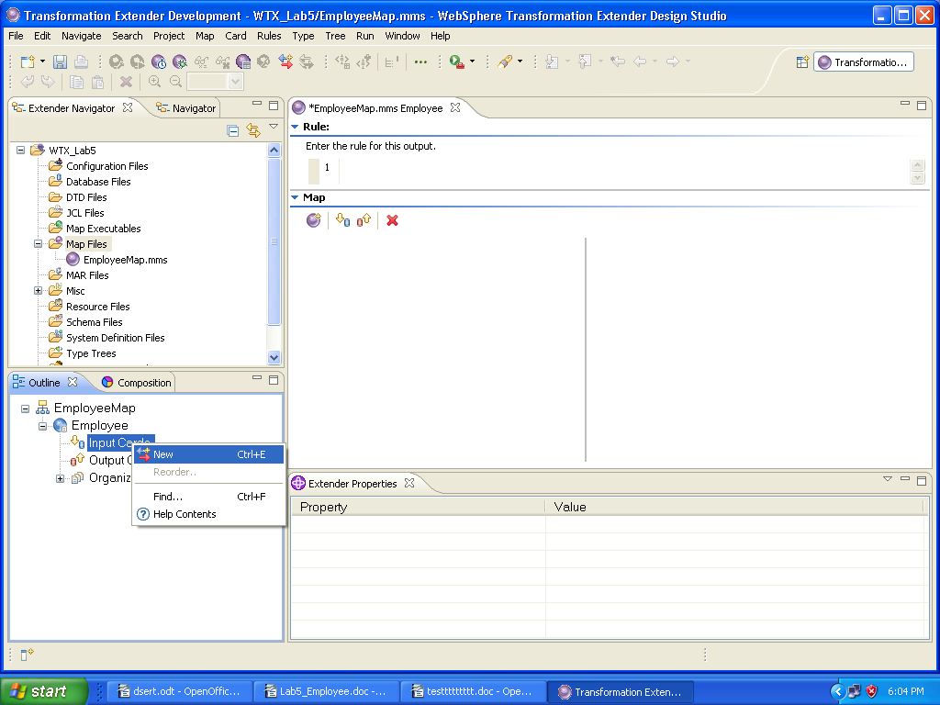

Step 10 :

Edit input card settings

The following steps are shown in detail
- Name the Card.
- Add a type tree
- Select Type
- Add Source adapter (File)
- Specify the File path

In the Value cell of the Schema→Card Name field, type EmployeeData.
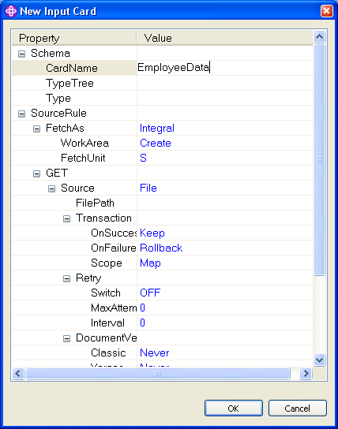

Step 11:

Click in the Type Tree Value cell and use the wizard button to bring up the Select type tree dialog.

Browse to WTX_Lab5. Click on Employees.mtt. Click OK.

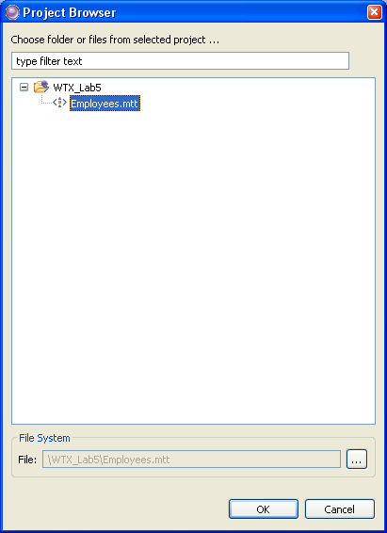

The following screen shot displays the populated type tree field

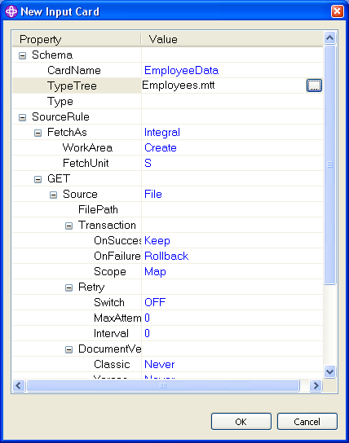

Step 13:

Click in the Type field Value cell, and use the wizard button to bring up the Select Type dialog.

Object Employee defines the data structure of the input data. Select and click OK.

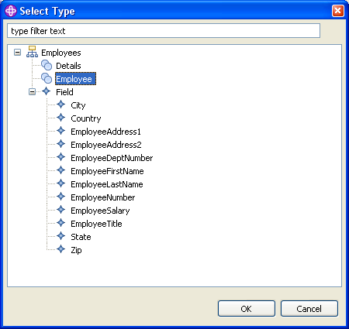

The following screen shot displays the populated type field

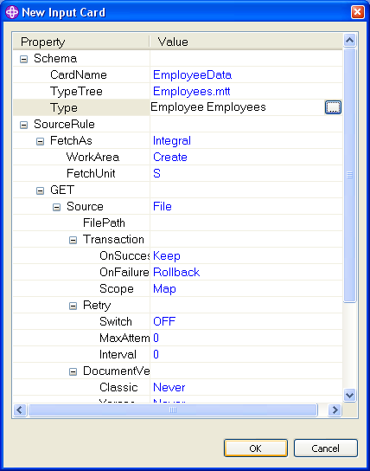

Step 14 :

Click in the Value cell of the FilePath field and click the wizard button to bring up the Select Data File dialog. Browse to WTX_Lab5 and Select EmployeeDetails.txt. Click OK.

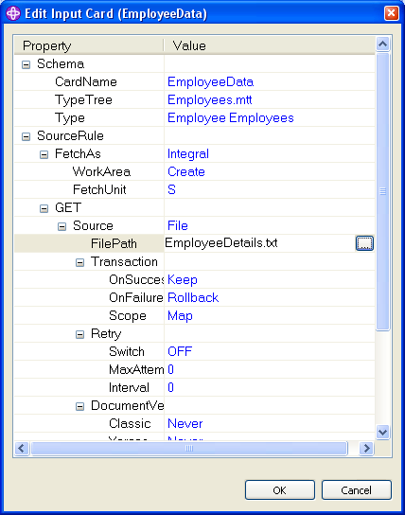

Step 15: Create and edit an output card

Repeat the same steps (Step 9 to Step 14 ) for creating an Output card,Select the Output Cards element under the map in the Outline view. On the Card menu, click New. The Add Output Card dialog box is displayed
Define the card by entering the appropriate information for each setting.

Click OK. Give the card settings information and the final card screen shot.

- Card Name
- Type Tree
- Type
- Target as File
- File Path Click OK, the Target Card is created.

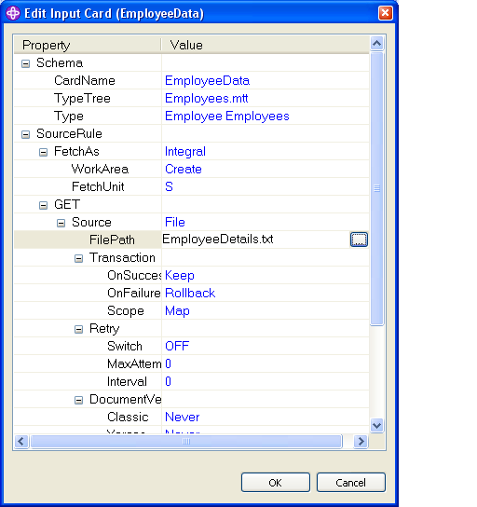

Step 16 :

Once the input and output cards are created the look and feel is as shown in the screen shot below.

A map is not complete until each rule cell has a map rule, or appears dimmed (the map rule is unavailable). Empty rule cells generate a build error when the map is built.

You will observe that the output is a group of records. To map a group in the input to a different group in the output, use a functional map. (Appendix B discusses in detail about functional maps)

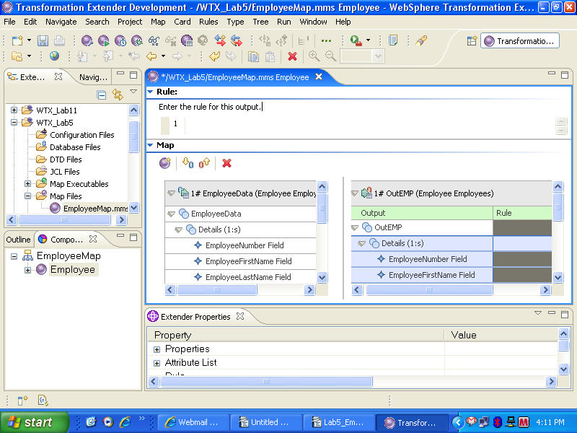

Creating a Functional map

Step 17:

Create a Functional map with name “f_Employee”. The Arguments passed in the functional map are the source group Details(s) as shown below.

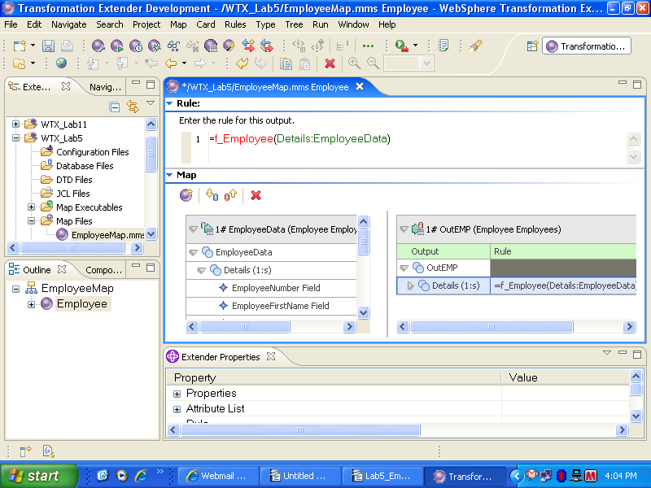

Step 18:

Press Enter. WebSphere TX rules execute once for each instance of its argument up to the maximum allowed by the range of the output.

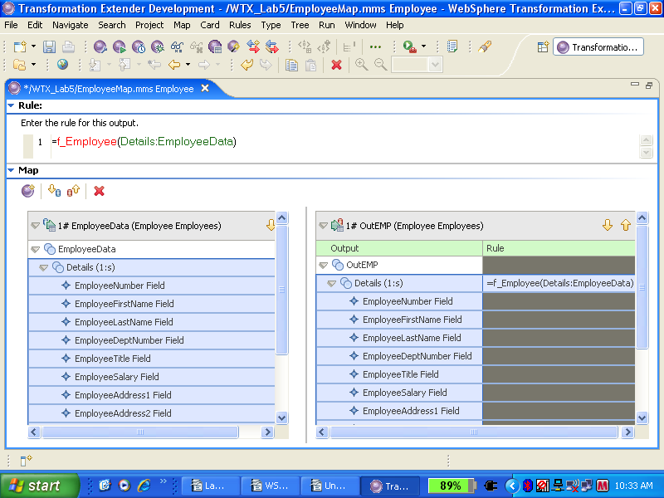

Functional Map Wizard

Step 19 :

Use the Functional Map Wizard to create a functional map (or maps) based on a map rule (or rules). The maps that the Wizard creates contain input cards and an output card, but do not contain map rules.

From the menu, select Rules→Functional Map Wizard. Or use the Functional Map Wizard icon on the toolbar.

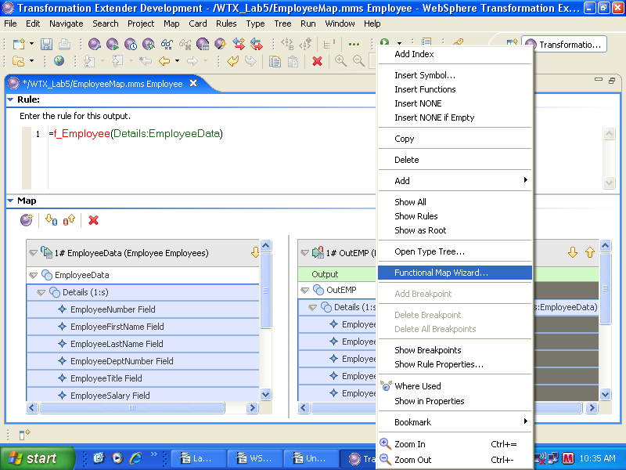

Step 20 :

Click Create for the required input and output card. Each input card and Output card represents a single data object.

The Type of the input card in a functional map must coordinate with the input argument(s) in the map rule on the executable map. If there is more than one input card in a functional map, ensure that the input card types correspond to the order of the input arguments. Functional maps have only one output card.

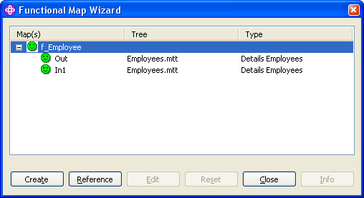
Click Close to create a functional map.

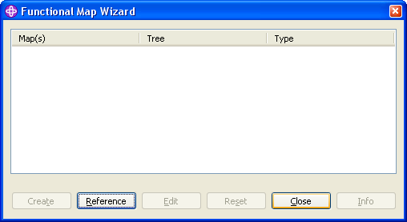

Step 21 :

A functional map f_Employee in a blue icon is created. Open the functional map (double click)

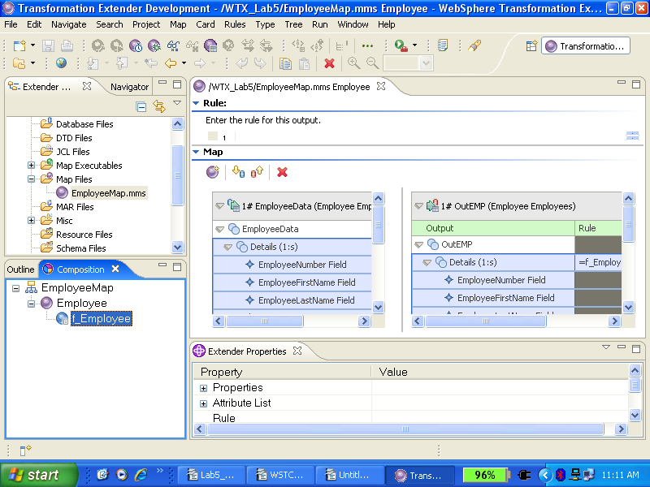

Step 22 :

Map the source data to target data by drag and drop.
Specify here, how to generate a particular output data object, or multiple independent objects, each of a particular type. Each output card has a rule column in which you enter map rules

Here we do a simple pass-through, i.e. Map the source data to target data by drag and drop the elements.

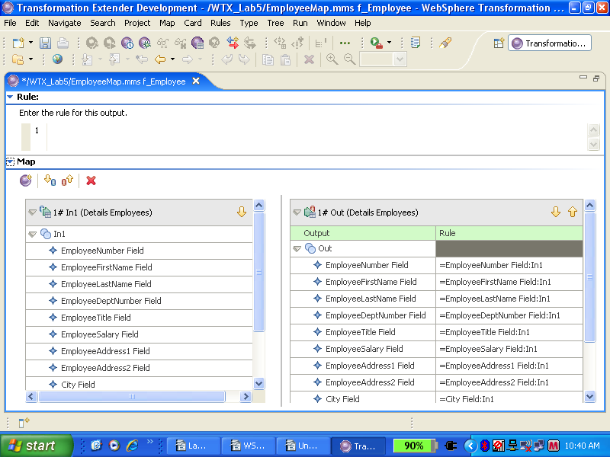

Maps need to be ‘compiled’ into a form that the transformation server can understand. It isn’t a true compilation process. The WebSphere TX server is a kind of virtual machine that executes a form of pseudo-code produced by the Map Designer.

Step 23 :
From the menu, choose Map→Build or choose the Build icon on the toolbar.

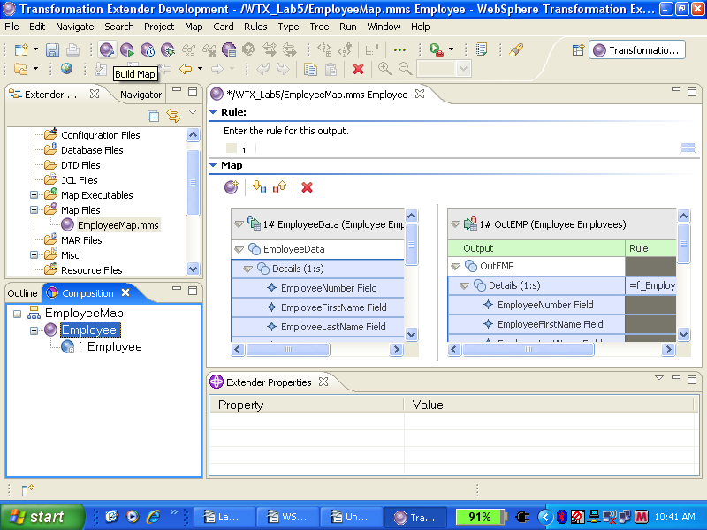

Assuming that everything has gone well, the Building Map window is displayed briefly and closes automatically.
The compiled map you just created is called Employee.mmc and is in the same directory as your Map Source File: C:\WTXTraining\WTX8.4\WTX_Lab5.

Step 24 :

From the menu, choose Map→Run. Or click the Run icon on the toolbar.

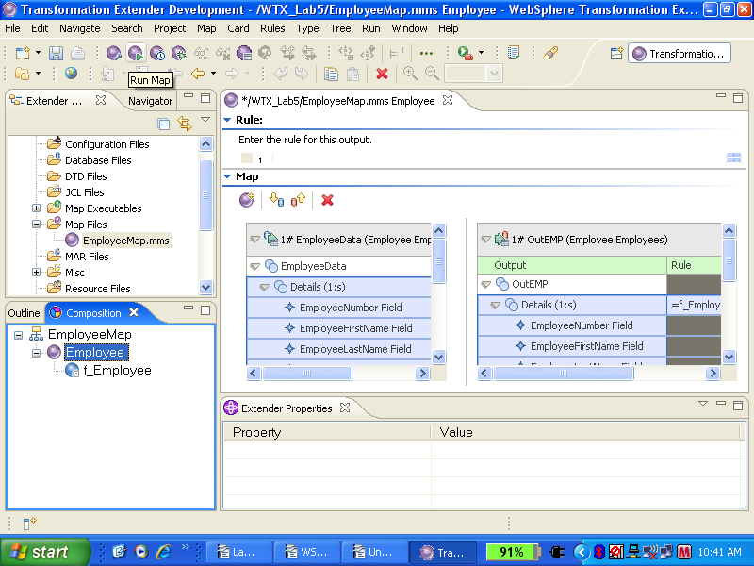

Step 25 :

When the map Run is done, the popup WTX Command Server window shows Map completed successfully as shown in below screen. Click Cancel. You can view any resulting build errors or warnings on the Build Results tab of the Organizer.

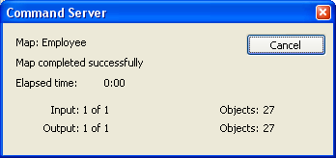

Step 26 :

To check the results, choose Map→View Run Results or click the View Run Results icon on the tool bar.
Be sure the focus is on the Executable map, Employee.

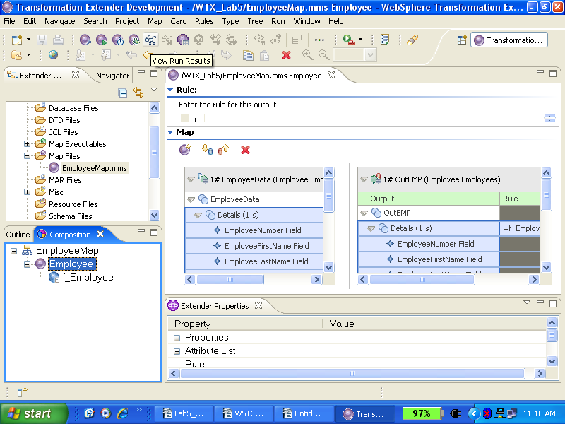

Step 27 :

If you check the name of the map source file, you’ll see all the inputs and all the outputs for all maps in the file. If you check the name of a single map, you'll see all the inputs and outputs for that map. If you check individual cards, you’ll see only those cards. Check the map source file and then click OK in the Run Results Dialog.

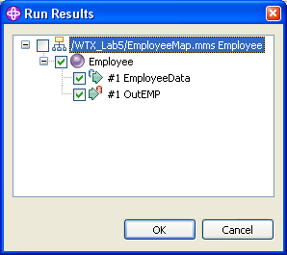

Final Output

Step 28 :
Your input and output files are displayed in tabbed views. Look at the results, and then close the windows.
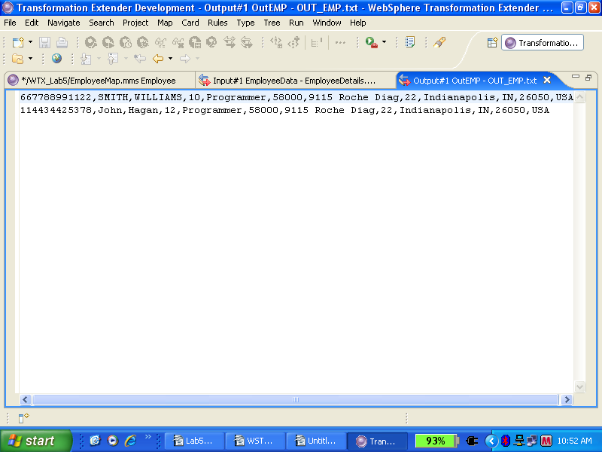

Step 29:

This will be a good time to save the work you did. Click the Save icon on the toolbar as shown below.

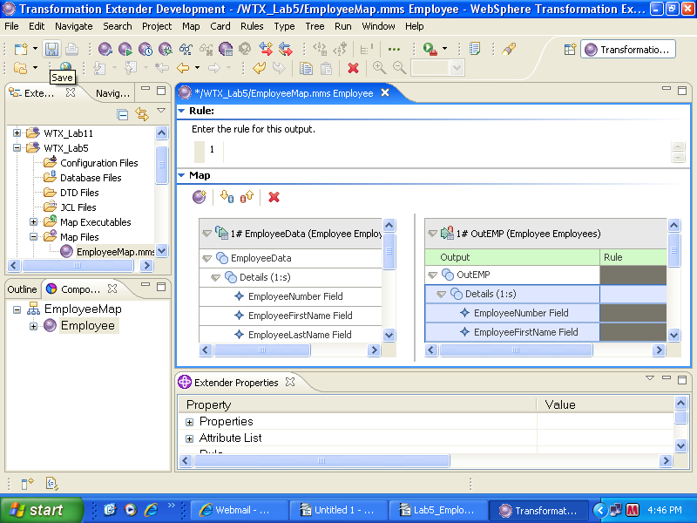

Points to remember

- Create maps to specify the logic necessary to transform the input data to the desired output data.
- Identify the source and data objects of the input data.
- Identify the target and data objects of the output data.
- Specify and build the output data according to the map rules.
- Provide information about data validation by generating trace files.
- View the run results of the map execution.

Limitation & Constraints:

Appendix A

Input and output cards

Input and output cards represent data objects. Each card represents one data object, which is defined as a particular type. There are two types of map cards: input cards and output cards.
- An input card contains the complete definition of an input for the map including information such as source identification, retrieval specifics, and the behavior that should occur during processing.
- An output card contains the complete definition of an output for the map including information such as target identification, destination specifics, and the behavior that should occur during processing.

Appendix B:

Functional map basics:

A functional map is like a subroutine; it maps a portion of data at a time. A functional is a map that is used like a function. It takes one or more input objects and generates one output object. For example, you might have a functional map that maps one Message to one row in a database table. Or you might have a functional map that maps one Header and one Detail to one ItemRecord.

The name of the functional map to be created is specified in the map rule. The name of the functional map must be unique within the map source file.
To easily identify functional maps, you may use a specific naming convention. Using the F_ prefix for all functional map names is a common practice. The functional map F_RecordMap is easily identified.

When to use a functional map:

The use of functional maps is very common. Almost every executable map created will use at least one functional map.

To map a group in the input to a different group in the output, use a functional map.
For example, use a functional map to map an input row to an output row when the rows are defined differently. Or, use a functional map to map from a file containing many input rows, to generate a file of many output rows with one output row per input row. The first output row would correspond to the first input row, the second output row corresponds to the second input row, and so on.
A map defines how to generate the output data. One important factor to consider in determining when to use a functional map is the presence of an output component with a range of more than one. For example, ranges of (s) or (1:10). The number of this output object to be created is based on the number of some input object.
Another important factor in determining when to use a functional map is when you want to transform the data - mapping from one or more types to a different type. In the preceding example of the functional map that maps one Message to one row in a database table, the input row and the output row are two different types.
Use a functional map when the number of a certain output group that you want to create is based on the occurrences of some input or output data - and the types are different types.

